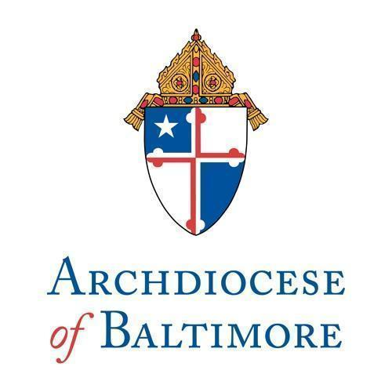

September 30, 2026

Most Reverend William E. Lori, S.T.D
Archbishop of Baltimore
320 Cathedral Street
Baltimore, MD 21201

Dear Archbishop Lori,

We hope this letter finds you well. In keeping with the effort to promote financial accountability and transparency among our Catholic Schools, we submit to you this annual certification on financial management for [INSERT SCHOOL NAME] for the Fiscal Year ended June 30, 2026.

Enclosed you will find:

- The completed Financial Governance Annual Checklist Certification with members signatures.
- A list of Financial Council members' names, occupations and email addresses.
- A list of the dates of the Finance Council Meetings during the Fiscal Year ending June 30, 2026 as well as whether the annual financial results were presented to the School Community.

If during your review of the provided information you or your staff have any questions or concerns please reach out to myself [Insert Principal/Presidents’s Name], our Business Manager [Insert Business Manager’s Name] or our Finance Council Chair [Insert Finance Council Chair’s Name].

Yours in Christ,

______________________________ _________________________
School Principal Finance Council Chair

Financial Governance Annual Checklist Certification
(Please complete annually by September 30th)

Parish/School Name: _________________________________

For the Fiscal Year Ended June 30, 2026

Please check the boxes next to the ten statements below if your finance council agrees with each statement. If there is disagreement on the statement then please leave it unchecked and provide a statement below. Indicate if there are any areas that you would like to further discuss or receive more information and a representative from the Division of Fiscal Services will contact the parish/school and provide support as needed.

 | ☐ | We believe that each member of the Parish/School Finance Council has met the requirements for membership on this Council, including Conflict of Interest requirements. The names of the Council members are made available to the Parish/School community.
 | ☐ | We believe each Council member has read the Archdiocesan Parish/School Finance Council policy and procedure during the past fiscal year, and is familiar with its contents.
 | ☐ | The Parish/School Finance Council met at least quarterly for the fiscal period and regularly reviewed and discussed the budget and all required financial statements. In addition:  - The annual and quarterly financial reports have been submitted to the Archdiocese.  - The annual financial report has been submitted to the Parish Community.  - The Pastoral Council has been provided with periodic financial updates and reports.
 | ☐ | We were provided with assurances from parish/school staff that they believe that the financial statements provided for review were orderly, accurate and complete and that:  - All bank accounts of the corporation are included on the balance sheet.  - Reconciliation of all bank accounts of the Parish/School Corporation were completed.  - All saving accounts, investments, IPLF deposits, endowments and/or other financial assets of the Parish/School Corporation are included on the balance sheet and reconciled with the financial institution they are in.  - All expenses for the period (regardless if paid or not) are included in the financial statements provided for review.  - Unpaid liabilities are discussed and understood by the Council members.
 | ☐ | The Parish/School Finance Council has been consulted during the past fiscal year with respect to acts of ordinary and extraordinary administration, if any. This includes consultation(s) with respect to the following:  - Management of Parish/School funds and banking arrangements.  - The construction, maintenance, renovation of sale of Parish/School facilities and rental agreements.  - Fund raising programs.  - Safety programs, and related insurance coverages.  - Review of new Parish/School policies and procedures.  - Monitoring and minimizing parish indebtedness
 | ☐ | We have reviewed and considered any audit reports issued by either the Archdiocese Internal Audit Department and/or outside parties, including related management letter comments and related communications, and have consulted on the Parish’s/School’s proposed action plan, if any.
 | ☐ | We have familiarized ourselves with the characteristics of an adequate system of internal controls and we have reviewed and discussed the current state of the Parish’s/School’s system of internal controls. Based on this, nothing has come to our attention where we would conclude that the current system of internal controls are inadequate.
 | ☐ | We have no knowledge of any fraud or suspected fraud affecting our Parish and/or School involving management, employees, volunteers or others. We have implemented positive pay for check and ACH on all bank accounts to reduce the risk of bank fraud.
 | ☐ | We have assisted the Pastor in monitoring the Parish school and Parish organizations, operating in the name of the parish and/or using the Parish’s federal and state tax exemption to ensure compliance with Archdiocesan policy, to understand financial impact to the parish and to ensure the parish’s tax-exempt status is not being jeopardized.
 | ☐ | We have not engaged in any activity with the parish or school from which we, or our family, could personally benefit. Any activity that could be considered a conflict of interest has been fully disclosed to the pastor and parish or school finance council and such conflict has been reviewed and approved by the parish or financial council.

Pastor/Principal _________________________ Signature _____________________ Date _________

Finance Council Signature Page
(Please complete annually by September 30th)

Name | Signature | Date | Signed with Exception
 |  |  | Yes, Item 10
 |  |  | Choose an item.
 |  |  | Choose an item.
 |  |  | Choose an item.
 |  |  | Choose an item.
 |  |  | Choose an item.
 |  |  | Choose an item.
 |  |  | Choose an item.
 |  |  | Choose an item.
 |  |  | Choose an item.

If Other is selected above or you would like to give further context behind the exception, please describe:

Financial Council Membership
(Please complete annually by September 30th)

Name | Occupation | Email

Financial Council Meetings
(Please complete annually by September 30th)

Date | Primary Topic | Quorum
 |  | Choose an item.
 |  | Choose an item.
 |  | Choose an item.
 |  | Choose an item.
 |  | Choose an item.
 |  | Choose an item.
 |  | Choose an item.
 |  | Choose an item.
 |  | Choose an item.
 |  | Choose an item.
 |  | Choose an item.
 |  | Choose an item.
Does the School provide an annual financial report to the school community (if yes please provide an electronic copy) |  | Choose an item.

