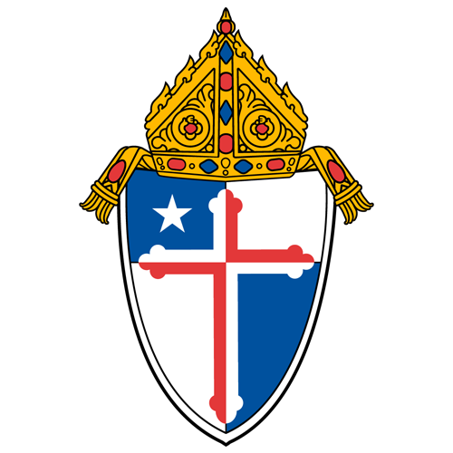

Archdiocese of Baltimore
Parish Finance Council Annual Trainings |  |  | Fiscal Year 2027
Date/Time | Topic/Contact |  | Registration and Meeting Link
October 20, 2026 @ 12:00 pm  October 21, 2026 @ 7:30 am | Introduction/Orientation  Ashley Conley |  | Registration  Meeting 12:00 pm  Meeting 7:30 am
November 10, 2026 @ 12:00 pm  November 11, 2026 @ 7:30 am | Stewardship  Kim Montgomery & Ashley Conley |  | Registration  Meeting 12:00 pm  Meeting 7:30 am
January 14, 2027 @ 12:00 pm  January 15, 2027 @ 7:30 am | Facilities | Real Estate | Risk Mgmt  Nolan McCoy & Tom Alban |  | Registration  Meeting 12:00 pm  Meeting 7:30 am
March 9, 2027 @ 12:00 pm  March 10, 2027 @ 7:30 am | Budgeting  Ashley Conley |  | Registration  Meeting 12:00 pm  Meeting 7:30 am
May 11, 2027 @ 12:00 pm  May 12, 2027 @ 7:30 am | Financial Mgmt | Internal Audit  Ashley Conley & Jason Geisinger |  | Registration  Meeting 12:00 pm  Meeting 7:30 am
Resources
Please see the new Parish Finance Council Resources webpage, here.
If you have any questions, please contact your parish’s Regional Controller.
John Matera: 410.547.5313 |  | Ashley Conley: 410.960.1292
Jane Andrews: jane.andrews@archbalt.org |  | Lisa Faherty: lisa.faherty@archbalt.org
Sharon Tornatore: sharon.tornatore@archbalt.org |  | Tracy Palmer: tpalmer@archbalt.org

