Maryland Department of Health (MDH)
Prevention and Health Promotion Administration (PHPA)

Maryland Center for Immunization

2022-23 Annual School Immunization Survey

- Survey Instructions -

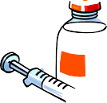
MDH 1013 (Formally DHMH 1013) 7-17

August 2022

- Introduction

Thank you for completing the 2022-2023 Annual School Immunization Survey. Please review the following instructions before you complete the survey. In accordance with Code of Maryland Regulations (COMAR) 10.06.04.09, ALL Maryland public and private schools are required to report the vaccination status of their students to the Maryland Department of Health (MDH) on an annual basis. The purpose of the Annual Report of School Immunization Status survey is to provide vaccination coverage estimates for school-aged children, ensure high vaccination coverage, and identify any areas of low coverage.

General Instructions:

  - Please complete all information in ink.
  - This survey is for students in Kindergarten through grade 12. Please do not enter information on preschool or Pre-K students.
  - Answer all questions. DO NOT LEAVE ANY QUESTIONS BLANK. A “0” (zero) may be used to either indicate missing information or valid numeric information indicating a count less than 1. If a section is not applicable to your school, please enter “0” in those boxes. If a question is left blank, we will assume that you missed the question and we will be contacting you to complete the information.

Minimum Vaccine Requirements:

Please refer to the “Vaccine Requirements for Children Enrolled in Pre-School Programs and in Schools, Maryland School Year 2022-2023” document to determine age-appropriate immunity for kindergarten through grade 12 enrollees. The minimum vaccine requirements and MDH COMAR 10.06.04.03 are available at https://tinyurl.com/yjh8vzdc An important reminder for the 2022-2023 year report, all 8th graders are required to have two (2) varicella vaccinations on record.

Non-graded students

These are students who are assigned to programs or classes without standard grade designation. These students should be recorded in the grade category that best corresponds with the students’ age. Please refer to the table below for additional guidance.

Student’s Age | Record in Grade Category | Review new or all student records
Age 5 | Kindergarten (K) | All
Age 6 to 11 | Grade 1 – 5 | New only
Age 11 to 12 | Grade 6 | New only
Age 12 to 13 | Grade 7 | New only
Age 13 to 14 | Grade 8 | New only
Age 14 to 18+ | Grade 9 – 12 | New only

Survey questions:

Sections A & B: Complete all contact/school information as indicated.

Question 1: Record the total number of ENROLLED students by grade level in the entire school. This count should include ALL students enrolled, regardless of whether they are newly enrolled or have medical/religious exemptions.

FOR QUESTIONS 2-13, INCLUDE ALL KINDERGARTEN STUDENTS AND ONLY NEWLY ENROLLED
STUDENTS TO YOUR SCHOOL BUILDING IN GRADES 1-12. Newly enrolled students refer to students in that grade who were NOT enrolled in your school building the previous year. If students are enrolling from a feeder school (i.e. Elementary to Middle; Middle to High), they would be considered NEWLY ENROLLED to your school and counted as NEW.

Question 2: Record the total number of NEW students by grade level currently enrolled in the entire school. This does not apply to Kindergarten where we ask for information on all Kindergarten students.

Question 3: The “Number of students who have a medical exemption” is a count of students with a documented (by a health care provider) permanent or temporary medical exemption or contraindication on file. THESE STUDENTS SHOULD NOT BE INCLUDED IN QUESTIONS 5-13.

Question 4: The “Number of students who have a religious exemption” is a count of students whose parents have signed the religious exemption portion of the official Maryland Immunization Certificate (DHMH 896). THESE STUDENTS SHOULD NOT BE INCLUDED IN QUESTIONS 5-13.
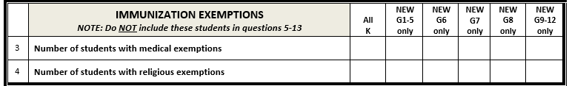

Question 5: The “Number of students with immunization records” is a count of students that have provided an immunization record regardless if they are up to date or not. **NOTE: Do not include students with medical or religious exemptions from questions 3 and 4 in this count.

Question 6: The “Number of students without immunization records” is a count of students that have not provided an immunization record. **NOTE: Do not include students with medical or religious exemptions from questions 3 and 4 in this count.

Question 7: The “Total number of students with and without records being reviewed” is a sum of the responses in questions #5 and #6.
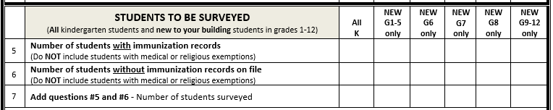

The questions in this section (questions 8-13) are designed to assess the number of students who NEED (i.e. doses are missing) one or more of the following vaccine doses listed. NOTE: STUDENTS WITH EXEMPTIONS ARE NOT COUNTED AS STUDENTS NEEDING A DOSE OF VACCINE AND SHOULD NOT BE INCLUDED IN THESE QUESTIONS.
EXAMPLE: If one newly enrolled student in 3rd grade needs one dose of Polio vaccine AND one newly enrolled student in 4th grade needs two doses of Polio vaccine THEN the TOTAL number of students needing one or more doses of Polio vaccines is 2.

Question 8: Number of students that NEED 1 or more doses of DTaP/Td/DT/Tdap vaccine: is a count of any student who has less than four doses required for students less than 7 years of age, and less than the three doses required for students 7 years and older.
**NOTE: Students in 7th – 12th grade are required to have 1 dose of Tdap vaccine.

Question 9: Number of students that NEED 1 or more doses of Polio vaccine: is a count of any student who has less than the required 3 doses of polio vaccine.

Question 10: Number of students that NEED 1 or more doses of Measles/Mumps/Rubella (MMR) vaccine: is a count of any student who has less than the required two (2) doses of MMR vaccine.

Question 11: Number of students that NEED 1 or more doses of Hepatitis B vaccine: is a count of students who have less than the required 3 doses of hepatitis B vaccine.

Question 12: Number of students that NEED 1 or more doses of Varicella vaccine: is a count of students who have less than the required number of varicella vaccine doses or no history of chickenpox disease. **NOTE: Students in grades K-4 are required to have 2 doses of Varicella vaccine.

Question 13: Number of 7th Grade students that NEED 1 dose of Meningococcal vaccine: is a count of 7th grade students who have no doses of Meningococcal vaccine. **NOTE: Students in 7th – 12th grade are required to have 1 dose of Meningococcal vaccine.

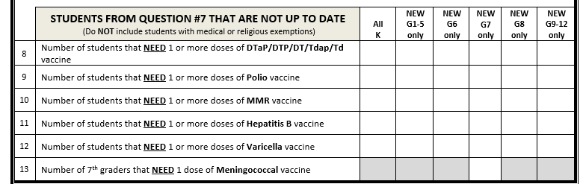

Submitting the Survey

The Annual Report (online OR paper) should be completed and submitted to MDH no later than Close of Business (COB) Friday, November 18, 2022.

The Annual Report of School Immunization Status questionnaire should be completed online at
https://www.surveymonkey.com/r/D9BB6SM

If you are unable to complete the online form, you may submit the enclosed Annual Report form by fax or mailing to the address on the form. Please note that the Annual Report survey should be submitted only once, either online OR on paper via fax or mail.

If you need assistance or need to make corrections after your submission, please call the Center for Immunization at 410-767-5716.

Frequently Asked Questions (FAQs) for the Annual School Immunization Survey

Do private schools have to complete the survey?
- Yes. The Code of Maryland Regulations (COMAR) 10.06.04.09 requires all Maryland public and private schools to report the vaccination status of their students to the Department of Health (MDH) on an annual basis.

Do I have to complete the survey if my school only includes pre-school or pre-kindergarten?
- No. Preschool and pre-kindergarten are not included in this survey.

Is this survey required for home schooled children?
- No.

Should I review the records of all students in grades K-12?
- For kindergarten students: Yes. All kindergarten records should be reviewed, including records of students who were enrolled in your pre-school program the prior year.
- For students in grades 1-12: No. You should only review the records of students who are newly enrolled in your school for this academic year.

Do I count students with exemptions as students who are in need of vaccines?
- No. Students with exemptions should not be included in your children who are in need of vaccines.

What should I record if I do not have information for one of the items?
- Please complete all fields. If a question does not pertain to your school, please fill in “0” (zero).

Can I include information for several schools on one form?
- No. You will need to create a separate form for each school. Each school must be a unique entry in the database. Please do not aggregate your data.

Can I print a copy of my online survey for my records?
- Yes, prior to clicking the “SUBMIT” button at the end of the survey, right click the survey and print it. If you have already completed the survey without printing it and would like a copy, please call the Center for Immunization at (410) 767-5716 and we will email or fax you a copy.

If I sent in the paper form do I need to complete the online survey?
- No. If you mailed or faxed in a hard copy, you do not need to complete the online survey. Although, we would prefer that you complete the online survey rather than fax or mail a hard copy.

Do I have to print and mail in a hard copy of the online survey?
- No. If you complete the online survey, you do not need to print and mail a copy in. You may want to print a copy for your own records though.

MDH 1013 (Formally DHMH 1013) 7-17

- CONTACT INFORMATION (PLEASE PRINT)
ANNUAL REPORT OF SCHOOL IMMUNIZATION STATUS 2019
Name of person completing report:

County/Jurisdiction:
(Distinguish Between Baltimore City and County)

Date report completed: / / 2019 Phone: ( )

SCHOOL INFORMATION (PLEASE PRINT)
Name of school:
E-mail:

Phone: ( )

Address:
City:
Zip: _

Grade levels (check all that apply):  K  1  2  3  4  5  6  7  8  9  10  11  12 Type of School (check one): public  private/non-public
 | STUDENT ENROLLMENT INFORMATION | Total K | Total G1-5 | Total G6 | Total G7 | Total G8 | Total G9-12
1 | TOTAL STUDENT ENROLLMENT - Include ALL ENROLLED students for each grade
2 | NEW STUDENT ENROLLMENT – Include only students NEW to the school building | N/A
NOTE: For the rest of the questions, consider ALL kindergarten students and ONLY NEWLY ENROLLED IN YOUR SCHOOL BUILDING grade 1-12 students. Students with exemptions should not be included in questions 5-13.

 | IMMUNIZATION EXEMPTIONS  NOTE: Do NOT include these students in questions 5-13 | All K | NEW G1-5  only | NEW G6  only | NEW G7  only | NEW G8  only | NEW G9-12  only
3 | Number of students with medical exemptions
4 | Number of students with religious exemptions
 | STUDENTS TO BE SURVEYED  (All kindergarten students and new to your building students in grades 1-12) | All K | NEW G1-5  only | NEW G6  only | NEW G7  only | NEW G8  only | NEW G9-12  only
5 | Number of students with immunization records  (Do NOT include students with medical or religious exemptions)
6 | Number of students without immunization records on file  (Do NOT include students with medical or religious exemptions)
7 | Add questions #5 and #7 - Number of students surveyed
 | STUDENTS FROM QUESTION #7 THAT ARE NOT UP TO DATE  (Do NOT include students with medical or religious exemptions) | All K | NEW G1-5  only | NEW G6  only | NEW G7  only | NEW G8  only | NEW G9-12  only
8 | Number of students that NEED 1 or more doses of DTaP/DTP/DT/Tdap/Td  vaccine
9 | Number of students that NEED 1 or more doses of Polio vaccine
10 | Number of students that NEED 1 or more doses of MMR vaccine
11 | Number of students that NEED 1 or more doses of Hepatitis B vaccine
12 | Number of students that NEED 1 or more doses of Varicella vaccine
13 | Number of 7th graders that NEED 1 dose of Meningococcal vaccine
Complete survey online at https://www.surveymonkey.com/r/D9BB6SM by Friday, November 18, 2022
If you are unable to complete online, return by fax or mail to:
Center for Immunization Maryland Department of Health
201 W. Preston Street, 3rd Floor, Baltimore, Maryland, 21201 Telephone: (410) 767-5716 Fax: (410) 333-5893

