Migrating ParishSOFT Contribution Data

- Envelopes Without Matching Contributions: These are families that have never made a contribution, the Send Envelopes box IS checked and they have an envelope number > 0.
Note: Because they have never made a contribution, a Donor record will not be created during the migration and thus the envelope numbers will not be either.

- PS Funds Without Matching Contributions: These are PS funds that have never had a contribution posted against them.
Note: These will not migrate to MP. If needed later, than can be created in MP.

- MP Program Funds
What you have come to know as funds in ParishSOFT are known as Program Funds in MP. As part of this migration, we are cleaning up the PS Funds before loading them into MP.

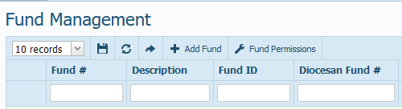

This spreadsheet has 2 tabs:

- Program Funds MP – Updated: The primary 4-digit AOB codes that are used and provided from AOB Fiscal department. The ones listed in Black are non-tax deductible; the ones listed in Red are tax deductible.

- Program Funds Sub Codes: are examples of what is needed regarding adding a 2-digit sub codes. Note: Each parish has the ability to designate these and they will not match parish to parish.

- Adding Diocesan Numbers to PS Funds
Instructions for adding the 4-digit and 2-digit sub code to your existing PS Funds)

- For example, in ParishSOFT via the Funds tab, located under Offertory:
Click the Edit button for the fund on the Fund Management screen.

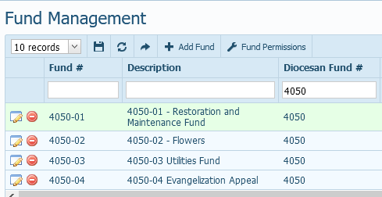

- When the fund displays, Click the Edit button

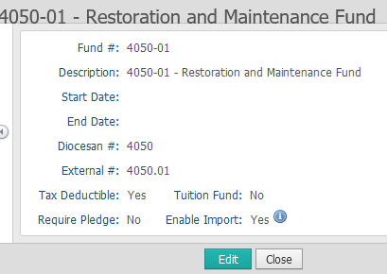
- In the Diocesan # field, enter the 4-digit AOB code, along with a 2-digit sub code.

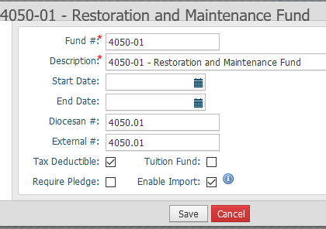

- Click Save
The fund will display what you have entered.

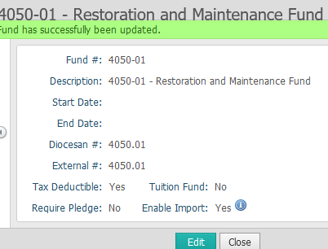

- Click Close to return to the Fund Management screen. The Fund Management screen will display your updated entry.

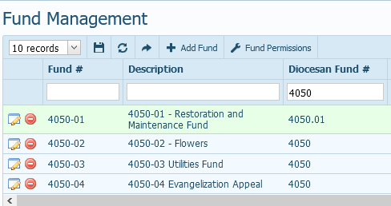

- You would need to do this for all of your ParishSOFT funds. The Program Funds Sub Codes tab from the spreadsheet can be used for guidance.
Note: This is needed so that your MP Program funds will reflect the correct donations/contributions and display the correct donations/contributions).

For questions, issues, and comments, send an email to:

ministryplatform@archbalt.org

