**Preparing your ParishSOFT Data for Migration**

In an effort to ensure your data migrate successfully, enter any and all missing data if possible. Here are some ways that you can perform to determine and update missing data for your Family and Member records.

**1. IQ queries:**

I created two IQ queries: **Family Query for PS Migration and Member Query for PS Migration**, that can be executed and exported to excel which can be used to assist in checking and updating missing family and member records in ParishSOFT.

Both required you to know your ParishSOFT ID (POL) **- send an email if you do not know your ParishSOFT ID (POL).**

To access these queries:

* Click the IQ tab.
* On the Intelligent Query screen, select **My Queries**:

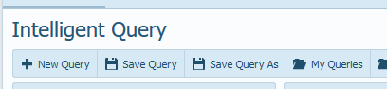

* On the My Queries screen, click the column heading, **Date Created** to place the queries in ascending order (the triangle is pointing up)

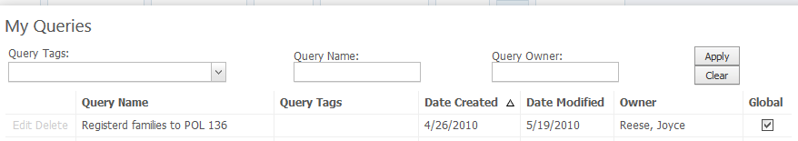

* Click the column heading, Date Created again to place the queries in descending order (the triangle is pointing down). You should see the queries.

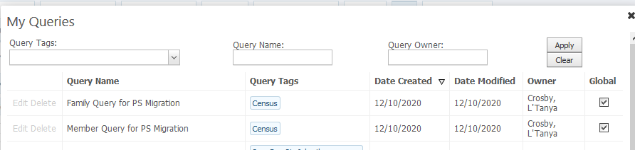

* Run the queries to get a list of family records or member records that contain missing data. The list can be exported.
* Update the missing data in ParishSOFT.

**2. Family List screen**

On the Family List screen, sort each column to ensure data displays.

Example:

Click the Family column heading once so that the triangle points down.

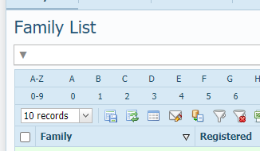

This should display your family list in descending (Z-A)

Click the Family Column heading again so that triangle points up.

This should display your family list in ascending order (A-Z). If family names are missing, they will display first (they will be blank)

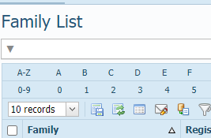

If information for family names are missing, the record needs to be updated to reflect the family names. This will require you to open the family record to display the Family Detail screen and enter the required information:

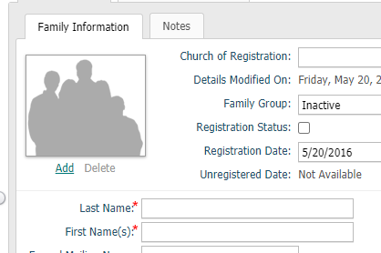

**Other items to check via the Family List screen:**

If the Family Group is marked deceased on the Family Information screen:

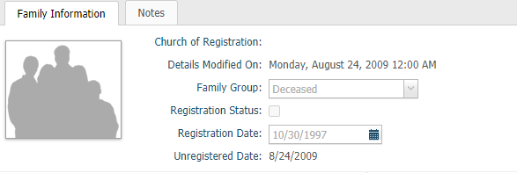

Be sure these fields are deselected and the envelope number is set to 0.

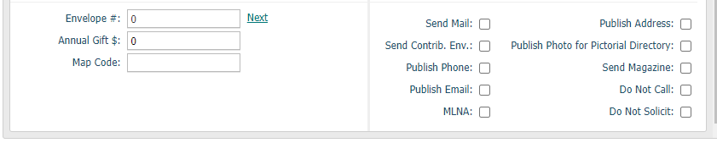

**Perform the sorting for the following columns to see if information is missing.**

Family Group: make sure no family is listed as **No Family Group**, change this to **Inactive**

**Be sure data is enter for:**

**City**

**State**

**Postal Code**

**Primary Address:** if Primary Address is listed as **No Address Text On File** and you are unable to locate and enter a correct address, open the record and remove any questionable data.

For example:

This record is listed with No Address Text On File and the address is unknown.



When I open the record, I can see the Country displaying, Send Mail, Publish Phone, Email, and Address are selected. In this case, the country should be removed and Send Mail, Publish Phone, Email and Address should be deselected.

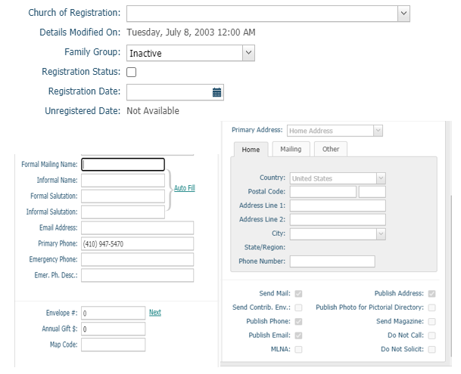

**3. Member List screen**

**Perform the same tasks for the Member List screen.**

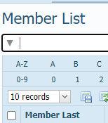

For the following columns:

**Member Last**

**Member First**

**Family Last Name**

**Gender:** be sure no one is listed with a U (unknown) as their gender. If U is displayed, you will need to change that to a M or F.

**Other items to check via the Member List screen:**

If there is a husband and wife or head and wife or head and husband, be sure the their marital status displays Married or Widowed if one is deceased.

If someone is deceased, be sure their member status is set to deceased:

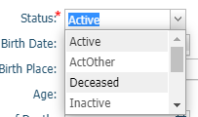

**Role:**

Be sure the correct role is selected.

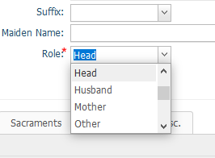

**Roles in ParishSOFT are Household Positions in Ministry Platform.**

Therefore, when your member data is migrated to Ministry Platform, your roles will fall into the following household postions:



Example: Head, Husband, Wife in PS will migrate to MP as Head of Household

Send questions to parishsoft@archbalt.org