Changing Your Password in Ministry Platform
INSTRUCTIONS

- Log in to Ministry Platform.

- Click on your Name (the upper right).

- On the User Account screen, expand the Change/Edit Password by clicking the > icon.
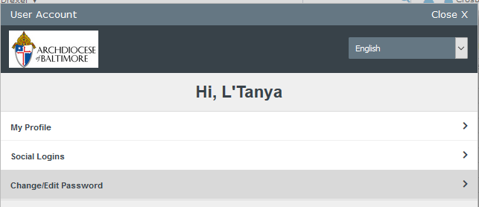

- Enter the required information.

- Click Save.
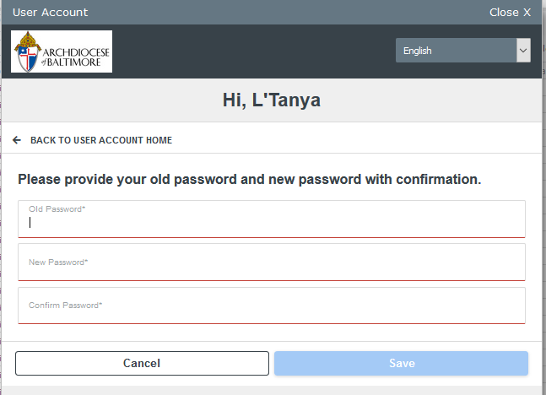

- You will see a Password Updated confirmation screen. Click Close.
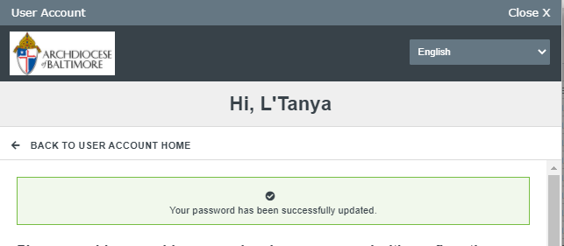

- Log Out of Ministry Platform, then Log In with your new password. You’re all set!

Questions and assistance, send an email to:
ministryplatform@archbalt.org

