Archdiocese of Baltimore Incident Report Entry Guide

- To report an injury, you will use this link that will take you to the AOB First Report of Injury Form:
AOB Claim Entry Form

- You will be directed to this page, and you will click on Submit a New Workers’ Compensation Claim – AOB Employees Only button.
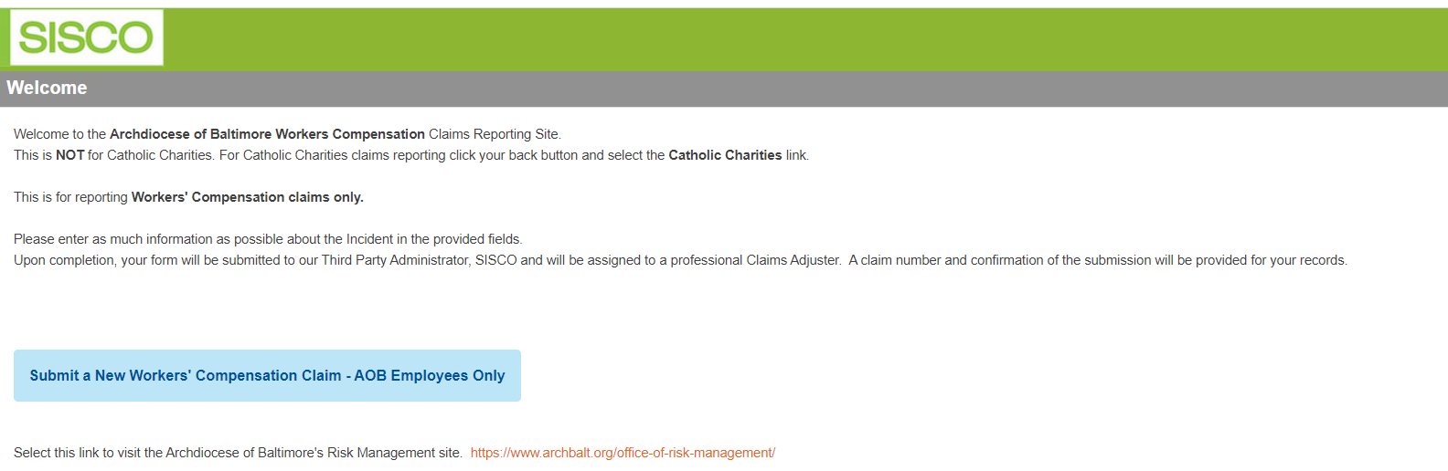

- On the reporting page, complete all known fields on the Incident Report. Required fields are notes with a red asterisk. Reminder: It is best practice to enter as much information as possible, even if it is not required.
- Further details for several of the required fields:
  - Department – Please select the applicable department and only select Other when there isn’t an appropriate option available
  - Incident Description field – Please include details on the incident but please refrain from using the injured employees name when describing the incident. You could instead refer to them as the “IE” for “Injured Employee”.
  - OSHA Recordable – Please visit this website for determining the correct setting for the incident. https://www.osha.gov/report.html
  - Reference Guide for icons displayed on claim entry screen

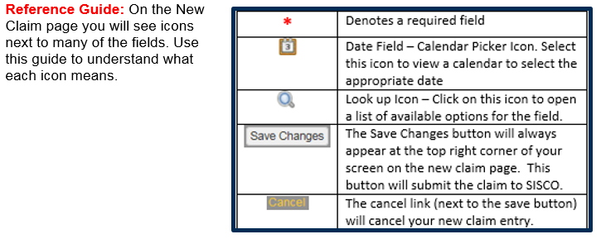

- Once completed, click the Save Changes button.
- When the claim has been submitted you will be directed to this screen, where you can retrieve the claim number.
- To upload any relevant files, click Upload File.
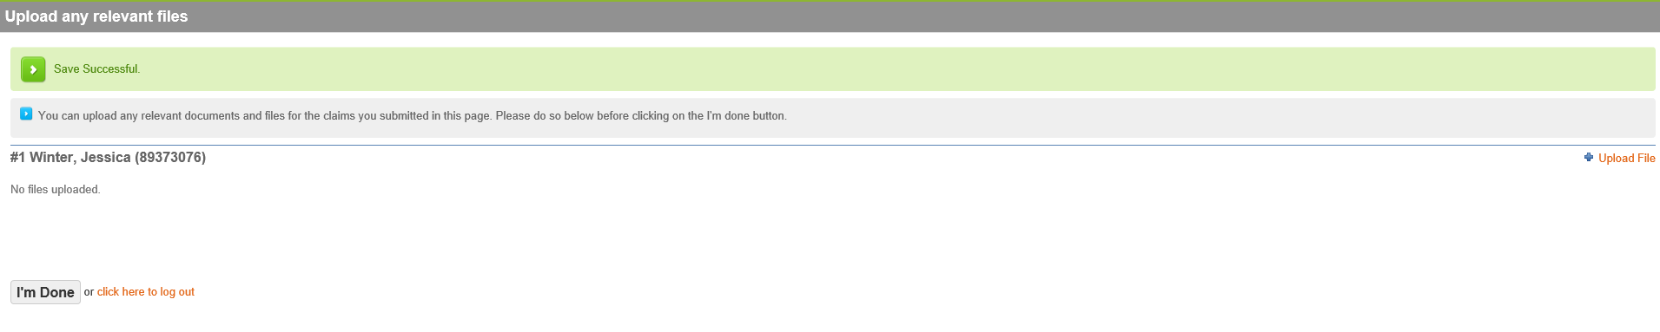
- Once the claim is submitted, a SISCO Supervisor will assign the claim to the appropriate adjuster for review.
For questions regarding the completion of the Incident Report, please contact Archdiocese of Baltimore Human Resources.
For technical questions or issues with this process, please email SISCO Support at: sisco.support@rcmd.com.

