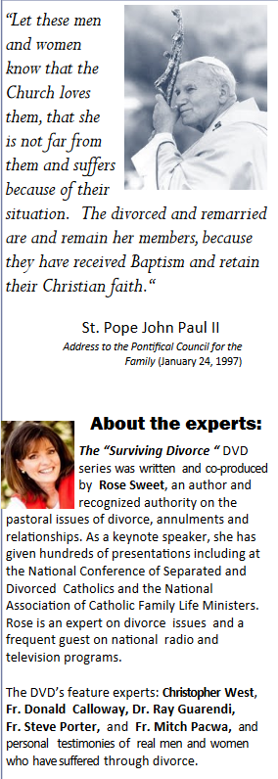 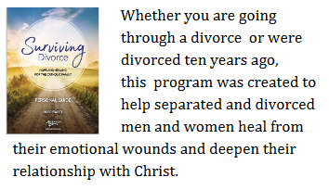

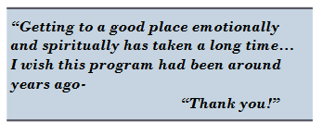

St Michael’s Divorce Care

Where: St Michael Catholic Church, Poplar Springs, Md

When: Every Thurday at 7:00 PM,

Starting Sept 19 until Dec 19

POC: DCN Harbey Santiago

PN: (410)980-2995

Email DeaconHarbey@Yahoo.com

