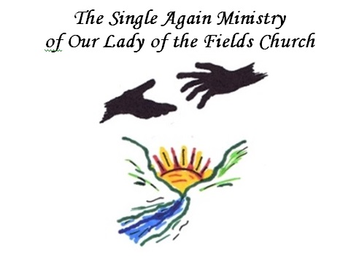
Meet and Greet
At St John’s Catholic Church
Room 18
10431 Twin Rivers Road
Columbia, MD 21044
All are welcome - singles, separated, divorced,
widowed, remarried. This event is to promote fellowship and healing.

Saturday, November 9, 2019
3pm-5pm, Mass at 5:30pm

Water will be provided
Please bring a snack to share.

For more information, please contact
Jeanne Hoover @ 410-206-1156 or Ministry4SingleAgain@gmail.com
Facebook: Single Again Ministry of Our Lady of the Fields

