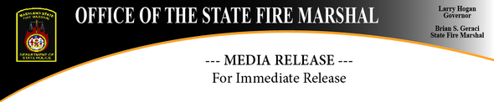

Haunted House Safety Guidelines To Look Out For This Halloween
STATEWIDE, October 7, 2019 - Many Marylanders will enjoy a variety special amusement buildings to celebrate Halloween this October. It is important to keep in mind that these structures have unique fire safety requirements in order to create an enjoyable and safe environment for everyone.
"Smoke machines, dim lighting, cramped corridors, and loud noises can create true terror for patrons if a fire occurs within a haunted house attraction," said State Fire Marshal Brian S. Geraci. "It is important for both owners and attendees to be vigilant when it comes to fire safety requirements at these venues."
As you and your family and friends attend the haunted houses located across Maryland this fall, look out for the following fire and life safety provisions.
- Approved automated sprinkler and smoke detection systems throughout the structure.
- At least two means of egress on every occupied floor, located as remote as possible from each other. These exits should be clearly marked by directional signage that is illuminated for enhanced visibility.
- Unoccupied floors and areas should be secured against unauthorized entry.
- Doors and passageways that are not an exit should be identified as "NO EXIT" to eliminate confusion. Every effort should be made to prevent occupants from accidentally traveling into a dead-end space in a fire emergency.
- Interior stairs and other vertical openings between floors should be properly enclosed, sealed, or otherwise protected against possible fire spread.
- Decorations, furnishings, and equipment should not obstruct, impair, or detract attention from the visibility or use of an exit. An exit cannot be a part of a mirrored wall.
- When the sprinkler or smoke detection systems activate, all conflicting sounds and visuals from the attraction should stop. Emergency lighting should also activate during this time.
- The structure must use non-combustible or limited-combustible materials such as gypsum wallboard, metal studs, brick, concrete block, etc. Extensive use of exposed plywood, wood paneling, or wood frame partitions can contribute to the ignition, spread and intensity of a fire.
- Smoking and the use of fireworks or open flame devices like cigarette lighters, candles, and kerosene heaters and lamps are prohibited inside or around the outside of the building. Signs indicating these restrictions should be clearly posted.
- One portable fire extinguisher should be located every 75 feet within the structure and located near exit signs.
- A crowd manager should be present at all hours of operation and occupancy guidelines must be met to avoid dangerous overcrowding.
- All exits must be unlocked and accessible at all times. They should be operational without the use of a key, tool, or special knowledge.
For more information about the Life Safety Code, visit NFPA.org or click here.

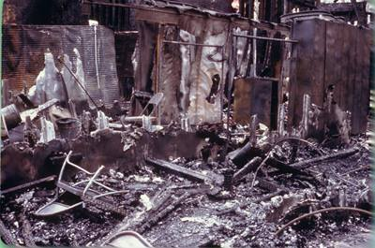
The control room after the 1984 Haunted Castle fire at Six Flags Adventure Park in Jackson Township, New Jersey that killed eight teenagers. Photo courtesy of NFPA.

The Office of the State Fire Marshal is an agency of the Department of State Police dedicated to helping protect citizens from fire and explosion through a comprehensive program of education, inspection, investigation and fire protection engineering. For more information on fire safety call 1-800-525-3124, log onto our website at: Maryland State Fire Marshal and/or our Facebook Page.

1201 Reisterstown Road, Pikesville, MD 21208
Having trouble viewing this notice? View it as a Web page.
https://content.govdelivery.com/accounts/MDFIRE/bulletins/262e1f1

---- MEDIA CONTACT ----
Emily Witty
Public Information Officer
Office 410-653-8999 Cell: 443-324-6876

