General Use Epinephrine Program
Policy and Procedures

Archdiocese of Baltimore
Department of Catholic Schools
Office of Risk Management
2019/2020 School Year

General Use Epinephrine Program

List of Contents
Introduction
Policy and Procedure
Statements of Authorization
Statements of Program Authorization
Statements of Authorization to Obtain and Store Auto-Injectable Epinephrine
Medical Authorization and Direction
Statements of Training
Training for All Staff Members
Training for Impacted Staff Members
Statement of Response Protocol and Follow-up Care
School Specific Response Protocol
Follow-up Protocol
Statement of Program Registration
Appendixes
- Maryland State Law 7-426.1
- Maryland State Law 7-426.3
- MSDE Epinephrine Policy Requirements- (SB 621) Frequently Asked Questions
- Standing Order Example
- Anaphylaxis Response Protocol
- Auto-injector Directions Example
- Report of Anaphylactic Reaction/Epinephrine Administration Form
- General Use Epinephrine Compliance Checklist

Introduction
This document was developed to assist schools wishing to implement a general use epinephrine program. The purpose of this document is to provide schools with a template for a general use epinephrine program that, when completed, is compliant with the standards set forth by Maryland State Law.
Please note that schools in the Archdiocese are not required to have a general use epinephrine program. If a school does elect to enact a general use epinephrine program, it must be registered with the Archdiocese of Baltimore Office of Risk Management as explained in this document.
Included is a template for a policy and procedure and related documents. The policy and procedure has blank areas that are for individual schools to input their unique information. It also contains a number of examples, such as a sample statement for a parent handbook. All of these fields need to be completed with the individual school’s information. Schools may use the examples provided or their own version.
To properly establish the program, it must meet all criteria in the General Use Epinephrine Compliance Checklist (Appendix H). This should be used as a guide when working on an individual school’s program and procedure. This checklist and required documents should be kept on hand in the health room, as well as submitted for approval by the Archdiocese of Baltimore Office of Risk Management. Programs need to be renewed annually or with any change in the physician/licensed prescriber or school nurse/other licensed health care practitioner.

For staff training resources, epinephrine auto-injector specific information, and information on programs that may help with the cost of auto-injectable epinephrine, please see the accompanying document “Epinephrine Resources.”

ENTER SCHOOL NAME
General Use Epinephrine
Policy and Procedure

Statements of Authorization

Statement of Program Authorization

Due to the rising incidence of anaphylaxis and the adoption of both Maryland State and National laws encouraging “stock” epinephrine, ENTER SCHOOL NAME., in accordance with its rules of governance, has authorized the implementation of this policy and procedure in accordance with Education Article 7-426.3 of Maryland State Law (Appendix B) as it relates to the availability and use of general use epinephrine. Through the adoption of this policy and procedure, ENTER SCHOOL NAME. has chosen to establish a policy authorizing school personnel to administer auto-injectable epinephrine, if available, to a student who is determined or perceived to be in anaphylaxis, regardless of whether the student has been identified as having an anaphylactic allergy or has a prescription for epinephrine.

ENTER SCHOOL NAME. has submitted a copy of this policy and procedure for the ENTER YEAR school year along with the completed “General Use Epinephrine Compliance Checklist” (Appendix H) to the Archdiocese of Baltimore Office of Risk Management.

ENTER SCHOOL NAME. has provided notification of the adoption of this policy to the school through the following means: ENTER DESCRIPTION

Furthermore, the following statement has been included in the parent handbook for the ENTER YEAR school year.
(Sample Statement)
As of [DATE], [SCHOOL NAME] has adopted a policy allowing the availability of stock epinephrine in the health suite for use in the event of an anaphylactic emergency. This epinephrine is for emergency use during normal school days and is not dependent on allergy history. It is not available outside of normal school hours or on field trips. Students with a known history of severe allergies are still expected to maintain emergency action plans, medical orders, and their own supply of emergency medication.

Statement of Authorization to Obtain and Store Auto-injectable Epinephrine

In order to establish this policy and procedure, ENTER SCHOOL NAME., in accordance with its rules of governance, has authorized the school nurse or other licensed health care practitioner to obtain and store auto–injectable epinephrine to be used in an emergency situation.

ENTER SCHOOL NAME. stocks both .15 mg and .30 mg doses of auto-injectable epinephrine in an unlocked cabinet available during the regular school day. This epinephrine will not be sent on field trips or be available outside of regular school hours. Emergency stock epinephrine is available during the school day to all students, staff, and school visitors regardless of their history of anaphylaxis. It is expected that individuals who have a known history of severe allergies continue to obtain individual medical orders, maintain an individual supply of emergency medications, and follow the school’s procedures for students at risk for an anaphylactic reaction.

It is further required that the school nurse or other licensed health care practitioner noted below be responsible for implementing this policy and maintaining the school’s auto-injectable epinephrine.

ENTER NAME OF SCH NURSE/LICENSED PRACTITIONER.

Name of Authorized School Nurse or Other Licensed Health Care Practitioner

________________________________________
School Administrator(s) Name(s) and Signature(s)

Medical Authorization and Direction

ENTER NAME OF PHYSICIAN/LICENSED PRESCRIBER. has agreed to and understands the requirements of providing medical authorization (a prescription) for procuring auto-injectable epinephrine, as well as for providing on-going medical direction for the implementation of the school’s general use epinephrine program in accordance with Education Article 7-426.3 of Maryland State Law (Appendix B).
By signing this document, ENTER NAME OF PHYSICIAN/LICENSED PRESCRIBER. has provided a standing order for auto-injectable epinephrine administration for anaphylaxis (See example- Appendix D), and acknowledges he or she has reviewed this document and found ENTER SCHOOL NAME to be in compliance with Education Article 7-426.3 of Maryland State Law. It is further understood by ENTER NAME OF PHYSICIAN/LICENSED PRESCRIBER. that this policy must be reviewed and signed again annually or sooner in the event of a change in the physician/licensed prescriber or school nurse/other licensed health care practitioner.

In an effort to afford protection to the physician/licensed prescriber, school nurse/other licensed health care practitioner, and other school personnel, this policy has been developed in accordance with article 7-426.3 of Maryland State Law. According to this article: Except for any willful or grossly negligent act, school personnel who respond in good faith to the anaphylactic reaction of a child in accordance with this section may not be held personally liable for any act or omission in the course of responding to a reaction.
Under the Baltimore Archdiocese insurance plan, prescribing physicians/ licensed prescribers who are acting as a volunteer for the school are covered under the Archdiocesan policy as long as the resources are available at a school for this policy to be fully implemented by the school nurse/other licensed health care practitioner, and the physician/ licensed prescriber does not provide hands-on care.

Statements of Training

Training for All Staff Members

ENTER SCHOOL NAME. provides annual training for all school personnel on how to recognize the signs and symptoms of anaphylaxis. This training is to be delivered by a licensed health care practitioner who is authorized to administer auto–injectable epinephrine and has been trained in an established protocol on how to recognize the signs and symptoms of anaphylaxis. The training offered at ENTER SCHOOL NAME. for the purpose of meeting this requirement must include the following:
- Overview of food allergies including:
  - The definition of a food allergy and anaphylaxis
  - A list of major allergens
- Review of the signs and symptoms of food allergies and anaphylaxis
- Explanation of medications for food allergies and anaphylaxis
- Discussion of the best practices for preventing exposure to food allergens:
  - Identification of manufacturer’s ingredient label on all classroom food
  - Consultation with parent to provide allergen free snacks from home
- Instruction as to the communication process during medical emergencies, including who to contact for help in an emergency
- Reminder of student privacy and confidentiality
- Instruction on the severity of anaphylaxis and the need for immediate response

All school personnel should be given a copy of the Anaphylaxis Response Protocol (Appendix E) and be made aware of the personnel in the building trained to respond to anaphylaxis.

Training for Impacted Staff Members

In addition to the anaphylaxis training described in the prior section, ENTER SCHOOL NAME. trains all impacted staff annually in responding to anaphylaxis and the proper use of the auto-injectable epinephrine. This training has been conducted for the ENTER YEAR. school year and a record of this training is maintained in the health room.
Attached to this policy and procedure is a list of the personnel who have been trained in the administration of auto-injectable epinephrine, and a copy of the anaphylaxis response protocol.
Training to meet this provision of the policy must include the following minimum requirements in addition to those in the section above:
- Train, practice and evaluate impacted staff administration of epinephrine auto-injector and location of the general use epinephrine auto-injector.
- Training shall include the use of the school’s clearly labeled pre-measured 135cm. string or pre-cut measuring tape. This tool, located alongside the school’s general use epinephrine injector, can be used to assist in the determination of dosage. Training shall also emphasize that if in doubt as to the size or weight of a child, the higher dose should be administered.
- Train, practice and evaluate impacted staff in activating the Anaphylaxis Response Protocol in case of a food allergy emergency
  - Immediately alerting 911 emergency medical services
  - Train, practice and evaluate communications with parents AFTER alerting 911
  - Training in school specific emergency logistical information
- Document training and evaluation of training

Statement of Response Protocol and Follow-up Care

School Specific Response Protocol

ENTER SCHOOL NAME. has developed a school specific response protocol for the emergency administration of auto–injectable epinephrine which includes the following minimum requirements:
- Injector specific training for impacted staff members.
- The distribution of clear step-by-step auto-injector specific instructions, and the posting of these instructions near the school’s general use epinephrine injector. (See Example Appendix F.)
- The training of all staff members and impacted staff members as described in the previous section, including training in the school’s Anaphylaxis Response Protocol and specific emergency logistical information. (See Appendix E.)
- Alongside the school’s general use epinephrine injector, the school will also store a clearly labeled pre-measured 135cm. string or pre-cut measuring tape to assist in the determination of dosage, and latex-free gloves.

ENTER SCHOOL NAME. has ensured that all impacted staff has been trained in the above protocol and have demonstrated competency in carrying out the emergency responses.

Follow-up Protocol

If at any time epinephrine is given at school, the Report of an Anaphylactic Reaction/Epinephrine Administration Form (Appendix G) must to be completed and copies given to the school administration, school nurse/other licensed health care practitioner, physician/licensed provider, and Archdiocese Office of Risk Management. The Report of an Anaphylactic Reaction/Epinephrine Administration Form is not to be submitted to MSDE Health Services. In addition, the follow-up protocol provides that the school nurse or other licensed health care practitioner must follow up with the student and his or her family to obtain the necessary forms and medications at school for a child with what is now defined as a known risk of severe allergic reaction.

Physician/Licensed Prescriber’s Signature____________________________________

By signing this document, the above Physician/Licensed Prescriber has provided standing orders and acknowledges that he or she has reviewed this document and all applicable documents and found them to be acceptable.

Statement of Program Registration

Program Registration

This program must be registered with the Archdiocese of Baltimore Office of Risk Management before it goes into effect. A copy of all paper work, including this policy and procedure, and all other documents should be maintained in the health room for reference.

ENTER SCHOOL NAME. has properly registered this program with the Office of Risk Management by submitting the completed plan and General Use Epinephrine Compliance Checklist (See Appendix H) for the ENTER YEAR. school year. Proper registration is evidenced by receipt of the signed General Use Epinephrine Compliance Checklist (Appendix H) and a certificate of insurance, listing the physician/licensed prescriber who is serving as a volunteer for the school as the certificate holder.

APPENDIX A
Maryland State Law
Article-Education

2017 Maryland Code
Education
Division II - Elementary and Secondary Education
Title 7 - Public Schools
Subtitle 4 - Health and Safety of Students
§ 7-426.1. Children with anaphylactic allergies.
Universal Citation: MD Educ Code § 7-426.1 (2017)
- (a) Definitions. --
  - (1) In this section the following words have the meanings indicated.
  - (2) "Anaphylactic allergy" means a food allergy that causes a severe, systematic reaction resulting in circulatory collapse or shock that may be fatal.
  - (3) "Employee" means an individual who is employed by a local board of education, including part-time employees, certified and noncertified substitute teachers employed by the local board of education for at least 7 days each school year, maintenance workers, and administrative staff.
  - (4) "Self-administer" means the application or consumption of medications in a manner prescribed by a health practitioner who is licensed, certified, or otherwise authorized under the Health Occupations Article to prescribe medications and medication delivery devices by the individual for whom the medication was prescribed without additional assistance or direction.
- (b) Reduction of risk. -- In consultation with a school health professional, the principal of a public school that has a child attending the school who has been identified to the school as having an anaphylactic allergy shall:
  - (1) Monitor the strategies developed in accordance with the Maryland State school health service guidelines to reduce the risk of exposure to anaphylactic causative agents in classrooms and common areas;
  - (2) Designate a peanut- and tree nut-free table in the cafeteria; and
  - (3) Establish procedures for self-administration of medication by the child if the child is determined to be capable of and responsible for self-administration by the principal, parent or guardian of the child, and physician of the child.
- (c) Revocation of authority of child to self-administer medication. -- A school may revoke the authority of a child to self-administer medication if the child endangers himself or herself or another child through misuse of the medication.
- (d) Immunity. -- Except for any willful or grossly negligent act, an employee who responds in good faith to the anaphylactic reaction of a child in accordance with this section is immune from civil liability for any act or omission in the course of responding to the reaction.
- (e) Waiver of liability by parent. -- If a child has authority to self-administer medication in accordance with subsection (b)(3) of this section, a local county board may require the parent or guardian of the child to sign a statement acknowledging that the school or its employee incurs no liability as a result of injury arising from self-administration by the child.

APPENDIX B
Maryland State Law
Article-Education

2018 Maryland Code
Education
Division II - Elementary and Secondary Education
Title 7 - Public Schools
Subtitle 4 - Health and Safety of Students
§ 7-426.3. Policy on use of epinephrine in nonpublic schools.
Universal Citation: MD Educ Code § 7-426.3 (2018)
- (a) Definitions. --
  - (1) In this section the following words have the meanings indicated.
  - (2) "Anaphylaxis" means a sudden, severe, and potentially life-threatening allergic reaction that occurs when an individual is exposed to an allergen.
  - (3) "Auto-injectable epinephrine" means a portable, disposable drug delivery device that contains a premeasured single dose of epinephrine that is used to treat anaphylaxis in an emergency situation.
  - (4) "School personnel" means individuals who are employed by a nonpublic school, including part-time employees, teachers and substitute teachers employed by the school for at least 7 days each school year, a school nurse, registered nurse case manager, delegating nurse, and administrative staff.
- (b) Establishment. -- Each nonpublic school in the State may establish a policy authorizing school personnel to administer auto-injectable epinephrine, if available, to a student who is determined to be or perceived to be in anaphylaxis, regardless of whether the student:
  - (1) Has been identified as having an anaphylactic allergy, as defined in § 7-426.1 of this subtitle; or
  - (2) Has a prescription for epinephrine as prescribed by an authorized licensed health care practitioner under the Health Occupations Article.
- (c) Contents. -- The policy established under subsection (b) of this section shall include:
  - (1) Training for school personnel on how to recognize the signs and symptoms of anaphylaxis by a licensed health care practitioner who is authorized to administer auto-injectable epinephrine and who has been trained in an established protocol on how to recognize the signs and symptoms of anaphylaxis;
  - (2) Procedures for the emergency administration of auto-injectable epinephrine;
  - (3) The proper follow-up emergency procedures;
  - (4) A provision authorizing a school nurse or other licensed health care practitioner to obtain and, school personnel to store, at a nonpublic school auto-injectable epinephrine to be used in an emergency situation;
  - (5) A requirement that the nonpublic school develop and implement a method for notifying the parents or guardians of students of the school's policy under this section at the beginning of each school year; and
  - (6) An ongoing process for oversight and monitoring by a licensed health care practitioner of the implementation of the policy established under subsection (b) of this section.
- (d) Immunity of personnel. -- Except for any willful or grossly negligent act, school personnel who respond in good faith to the anaphylactic reaction of a child in accordance with this section may not be held personally liable for any act or omission in the course of responding to the reaction.

Appendix C

Epinephrine Policy Requirements – (SB 621) Frequently Asked Questions
Lillian M. Lowery, Ed.D. | Joshua M. Sharfstein, M.D.
State Superintendent of Schools | Secretary

Senate Bill 621 (SB 621), codified under Maryland Code, Education Article section
7-426.2, requires local boards of education to create policies regarding the availability and use of auto-injectable epinephrine. The law went into effect on July 1, 2012. The following frequently asked questions (FAQ) address several key aspects of the new law.

What is anaphylaxis?

Anaphylaxis is a sudden, severe, rapidly progressive potentially life-threatening allergic reaction that affects multiple organ systems of the body at the same time. Anaphylaxis requires immediate medical attention as it can be fatal if not reversed within seconds or minutes of coming in contact with the allergen. Allergens such as insect stings or bites, foods (such as milk, egg, peanut, tree nuts, fish, shellfish, wheat, and soy¹), latex, medications and other allergens are common causes of anaphylaxis, but it may also be idiopathic or exercise-induced. Anaphylaxis usually occurs immediately (seconds or minutes) but also may occur several hours after allergen exposure. Symptoms progress rapidly, making it a medical emergency.

What are the signs/symptoms of anaphylaxis?

Organ System | Sign(s)/Symptom(s)
Mouth/Throat | Itching, tingling, or swelling of lips, tongue, or mouth; blue/grey color of lips; hacking cough; tightening of throat;  hoarseness; difficulty swallowing
Nose/Eyes/Ears | Runny, itchy nose; redness and/or swelling of eyes; throbbing  in ears
Skin | Facial flushing; hives and/or generalized itchy rash; swelling of  face or extremities; tingling; blue/grey discoloration
Gastroinstestinal (GI) | Nausea, abdominal cramps, vomiting, diarrhea
Lung | Shortness of breath; wheezing; short, frequent, shallow cough;  difficulty breathing
Heart | Thready or unobtainable pulse; low blood pressure; rapid pulse, palpitations, fainting; dizziness; pale, blue, or gray color of lips  or nail beds
Mental | Uneasiness; agitation; unconsciousness
Other | Any other symptom specific to an individual’s response to a specific allergen

1 According to the Food Allergy and Anaphylaxis Network (FAAN), these eight foods are estimated to account for 90% of all food allergic reactions. However, a person can be allergic to any food. For more information on food allergies visit the FAAN website at www.foodallergy.org and click on “About Food Allergy”.

MSDE, 200 West Baltimore Street, Baltimore, MD 21201 Phone (410) 767-0100; Statewide Toll Free 1-888-246-0016
DHMH, 201 West Preston Street, Baltimore, MD 21201 Phone (410) 767-5300; Fax (410) 333-7106; Statewide Toll Free 1-877-463-3464

What are the local policy requirements to comply with SB 621?

SB 621 requires local boards of education to develop policies regarding the use of epinephrine auto-injectors. The policy must authorize the school nurse and other school personnel to administer auto–injectable epinephrine to a student who is determined to be or perceived to be in anaphylaxis, regardless of whether the student: (1) has been identified as having an anaphylactic allergy, as defined in Education Article § 7–426.1; or (2) has a prescription for epinephrine from an authorized licensed health care practitioner under the Health Occupations Article.

The policy shall include:

  - Training on recognizing the symptoms of anaphylaxis;
  - Procedures for emergency administration of auto-injectable epinephrine;
  - Proper follow-up emergency procedures; and
  - Authorization for the school nurse to obtain and store the auto-injectable epinephrine.

What is the definition of “other school personnel” who may administer auto-injectable epinephrine?
The law does not define “other school personnel”. The local board’s policy may identify other school personnel to include, but not be limited to: school administrators, teachers, school psychologists, school counselors, pupil personnel workers, school social workers, food services staff, coaches/advisors for school sponsored activities, and bus drivers. Regardless of the service delivery model, the registered nurse is always the leader of the school health nursing team and may determine which school personnel are to be given the responsibility for administering auto- injectable epinephrine.

For additional information on ways other school personnel may be identified and trained to assist in an anaphylactic emergency, please refer to the Maryland School Health Services guideline “Management of Students at Risk for Anaphylactic Reaction” available on the Maryland State Department of Education (MSDE) website. ²

Does the new policy replace previous policies regarding students with a known history of anaphylaxis?

The policy required under SB 621 does not replace student specific orders or individual medications required to be provided by the parent/guardian. Parents of students with known life threatening allergies and/or anaphylaxis remain responsible for providing the school with written instructions from the student’s health care provider for the management of known anaphylaxis; and all necessary medications for implementing the student specific order(s) on an annual basis.

For additional information, please refer to the Maryland School Health Services guideline “Management of Students at Risk for Anaphylactic Reaction” available at the MSDE website.
2 All guidelines referenced in this FAQ may be accessed at www.mdschoolhealthservices.org; on the right side of the page, click on “SHS Guidelines, Table of Contents”

Does the law require schools to maintain auto-injectable epinephrine?

Yes. The law requires local boards to have a policy authorizing the school nurse to obtain and store auto-injectable epinephrine at public schools. In addition, the local board’s policy must authorize other school personnel to administer auto-injectable epinephrine if available at a public school.

It is crucial for local programs to consider the needs of their student population, the Emergency Medical System (EMS) response time, and any other factors necessary to determine the amount of auto-injectable epinephrine to stock in the school building.

Does the law require schools to provide auto-injectable epinephrine at related school events on or off campus?

No. This is not a requirement. However, the law specifically requires auto-injectable epinephrine to be available in the “the public schools,” which means each public school building. At the same time, the law does not limit the availability of auto-injectable epinephrine to the school building. Therefore, when the local board establishes its policy, appropriate policy may include authorizing the purchase of additional auto-injectable epinephrine to be available at related school events. In certain circumstances it may be good health policy to do so, and local boards should consult with their counsel and health department on this issue. The law does require schools to report to MSDE every incident “at the school or at a related school event that required the use of auto-injectable
epinephrine.” (e.g., field trips, sporting games, etc.).

Considerable guidance is provided regarding medication administration at school sponsored activities in the “Administration of Medication in Schools” guideline available at the MSDE website. In addition, the guideline for the “Management of Students at Risk for Anaphylactic
Reaction” includes a section titled “School Environment” that addresses how to assess the school environment for potential exposure to allergens on field trips, recess, and other school sponsored activities, and how to develop an implementation plan for emergencies.

Where should schools store auto-injectable epinephrine?
The auto-injectable epinephrine should be kept at room temperature (25°C, 77°F) until the marked expiration date, at which time it should be replaced. The effectiveness of the auto-injectable epinephrine may decrease after the expiration date. Therefore, care should be taken to routinely check the expiration date and promptly refill the prescription before the expiration date. The auto- injectable epinephrine should not be refrigerated or exposed to extreme heat or light.

Since use of the auto-injectable epinephrine must be administered within a short time after allergen exposure, consideration should be given to the layout of the school, health services staffing model, and the size of the student population in determining the placement of the stock epinephrine.

Additionally, in compliance with the School Health Services Standards (COMAR 13A.05.05.05--
.15), all medication must be stored in a locked cabinet. Access to medication locked in the designated space shall be under the authority of the designated school health professional, the principal, and/or designee.

Who provides and evaluates the training of other unlicensed school personnel to administer auto-injectable epinephrine?
Training on the management of anaphylaxis in the school setting is generally done by the school registered nurse. The school registered nurse may monitor and evaluate the training of other unlicensed school personnel to administer auto-injectable epinephrine. However, the local board may designate other qualified health care providers in the school setting, such as a physician and certified registered nurse practitioner (CRNP), to conduct the training.

The school registered nurse may need to conduct training for school personnel at various levels, such as: (1) general training for all school personnel; (2) training for school personnel in frequent contact with students at risk for anaphylactic reaction; and (3) specialized training for the management of anaphylaxis/response to anaphylaxis emergency in the school setting.

Who can purchase auto-injectable epinephrine for administration in schools?

The local board may designate any individual authorized to prescribe medication, such as a nurse practitioner or physician, to purchase auto-injectable epinephrine directly from a wholesale drug distributor or retail pharmacy. (See Md. Code, Health Occup. Art. §12-6C-09(b).) The designee may then distribute the medication for administration in schools in accordance with the local board’s policy.

In addition, the inventory of auto-injectable epinephrine should be audited periodically for expiration dates to help ensure maximum efficacy of the medication.

By what authority may an unlicensed individual administer auto-injectable epinephrine to students at school?

The General Assembly, through SB 621, has authorized local boards to establish a policy to train and enable an unlicensed individual to administer auto-injectable epinephrine to a student at the school.

What is the liability of unlicensed school personnel for administering auto-injectable epinephrine in a medical emergency?

In Education Article §7-426.1, there is a specific immunity provision for an employee who responds in good faith to an anaphylactic reaction of a child. Liability protections are available to local school employees under Maryland law. Pursuant to Education Article § 4-106 and Courts and Judicial Proceedings Article § 5-518, local school system employees acting within the scope of their employment, without malice and gross negligence, are not personally liable for damages resulting from a tortious act or omission .

In addition, other legal protections and defenses (such as the “Good Samaritan Law”, Courts and Judicial Proceedings Article § 5-603) may be available for qualified individuals.

Where can I find additional resources on this topic?

- Maryland State School Health Services Guidelines (www.mdschoolhealthservices.org; click on “SHS Guidelines, Table of Contents):

“Management of Students at Risk for Anaphylactic Reaction” (2009)

“Emergency Management Guidelines for Individuals in Schools with an Unknown History of Anaphylaxis or Severe Allergic Reactions” (2003)

“Administration of Medication in Schools” (2006)

- National Association of School Nurses (NASN) Anaphylaxis Planning Algorithm.

- National Association of School Nurses (NASN) Anaphylaxis Provision of Care Algorithm http://www.nasn.org/ToolsResources/FoodAllergyandAnaphylaxis/AnaphylaxisProvisionofC are Algorithm.

- National Association of School Nurses (NASN), Food Allergy and Anaphylaxis: An NASN Tool Kit, http://www.nasn.org/ToolsResources/FoodAllergyandAnaphylaxis

- Food Allergy and Anaphylaxis Network (FAAN) http://www.foodallergy.org/page/address- transportation-issues

- EpiPen http://www.epipen.com/

Who can I contact for additional information?

- Maryland State Department of Education (MSDE), School Health Issues Section

  - Alicia Mezu, MSN/Ed, RN, Health Services Specialist,
(410) 767-0353, amezu@msde.state.md.us

Department of Health and Mental Hygiene (DHMH), Office of School Health

  - Cheryl De Pinto, MD, MPH, Medical Director
(410) 767-5595, cheryl.depinto@maryland.gov
APPENDIX D
STANDING ORDER
AUTO -INJECTOR EPINEPHRINE ADMINISTRATION FOR ANAPHYLAXIS

In the event of an anaphylactic reaction in an individual in the school setting, epinephrine will be administered by the school nurse or trained unlicensed school personnel. This Standing Order is for the use of auto-injector epinephrine in such situations.
In the case of students with a history of anaphylaxis or other severe allergic reactions, epinephrine should be administered according to specific individualized prescriptive orders documented in their individualized health care plans. If no such orders exist or are not readily available, the Standing Orders given in this document should be used.
DEFINITION: Anaphylaxis is a severe allergic reaction which can be life threatening and can occur within minutes after a triggering event or up to hours later.
CAUSES: Extreme sensitivity to one or more:
      - Food
      - Latex
      - Exercise Induced
      - Idiopathic (Unknown)
      - Medication
      - Insect stings
      - Asthma
      - Other
PHYSICAL FINDINGS:
Common symptoms associated with anaphylaxis:
- Difficulty breathing, wheezing
- Hives, generalized flushing, itching, or redness of the skin
- Swelling of the throat , lips, tongue, throat ; tightness/change of voice
- Difficulty swallowing
- Tingling sensation, itching, or metallic taste in mouth
- Feeling of apprehension, agitation
STANDING ORDER:
- Based on symptoms, determine that an anaphylactic reaction appears to be occurring. Act quickly. It is safer to give epinephrine than to delay treatment. Anaphylaxis is a life-threatening reaction.
- If you are alone and are able to provide epinephrine, call out or yell for help as you immediately go get the epinephrine. Do not take extra time seeking others until you have provided the epinephrine.
- If you are alone and do not know how to provide epinephrine, call out or yell for help. If someone is available to help you, have them get the personnel trained to provide epinephrine and the epinephrine while you dial 911 and follow the dispatcher's instructions. Advise the 911 operator that anaphylaxis is suspected and epinephrine is available. Your goal is to get someone (EMS or trained personnel) to provide epinephrine and care as soon as possible.
- Select appropriate epinephrine auto-injector to administer, based on weight or height. If possible use pre-measured string to help determine dose:

Dosage: 0.15mg Epinephrine auto-injector IM, if less than 66 pounds/shorter than 135cm
0.30mg Epinephrine auto-injector IM, if 66 pounds or greater/taller than 135cm
- Frequency: If symptoms continue, a second dose should be administered 5 to 15 minutes after the first dose
- Inject epinephrine via auto-injector: Pull off safety release cap. Swing and jab firmly into upper, outer thigh, (through clothing if necessary). Hold in place for 10 seconds to deliver medication and then remove. Massage the area for 10 more seconds. Note the time.
- Call or have a bystander call 911 immediately or activate the Emergency Medical System (EMS). Advise the 911 operator that anaphylaxis is suspected and epinephrine has been given.
- Keep the individual either lying down or seated. If they lose consciousness, check if they are breathing and have a pulse. If not, begin CPR (cardiopulmonary resuscitation), call out for help and continue CPR until the individual regains a pulse and is breathing or until EMS arrives and takes over.
- Call School Nurse/Front Office school personnel and advise of situation.
- Repeat the dose after 5 to 15 minutes if symptoms persist or return.
- Stay with the individual until EMS arrives, continuing to follow the directions in No. 7 above.
- Provide EMS with Epinephrine auto injector labeled with name, date, and time administered to transport to the ER with the student.
FOLLOW UP (to be done the same day as the event):
- Assure parents/guardians have been notified.
- Complete required documentation of incident.
- Order replacement epinephrine auto injector(s).
Physician/Licensed Prescriber Signature Date Print Name, please ENTER NAME.
- Effective for School Year ENTER SCHOOL YEAR.
*Must be renewed annually and with any change in prescriber.

APPENDIX E
Anaphylaxis Response Protocol

Location of General Use Epi-Pen ENTER LOCATION.

Emergency number(s) ENTER PHONE NUMBER(S).
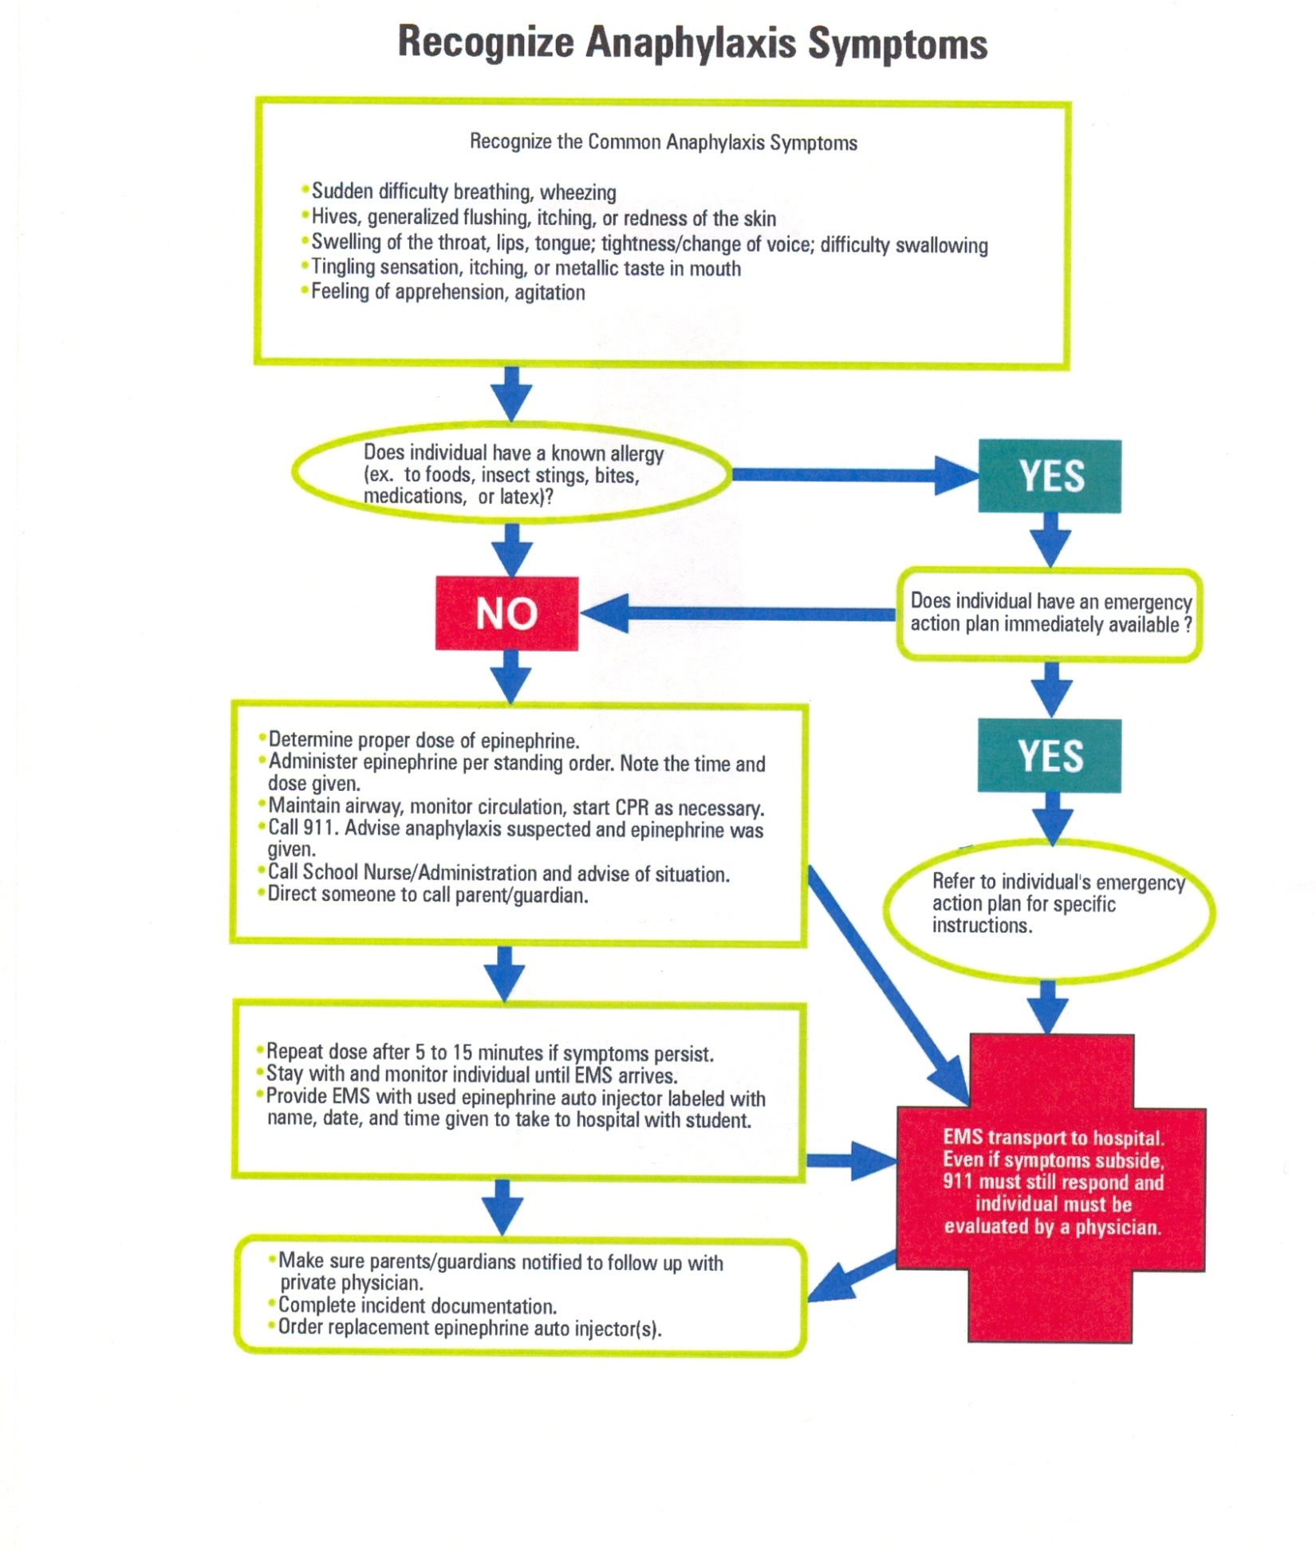

Dosage (use pre-measured string if possible):
* 0.15mg (Junior Dose) IM : Children <66lbs/ shorter than 135cm
* 0.30mg IM (Regular Dose) Individuals >66lbs /taller that 135cm (Approx. 2nd grade and up)

APPENDIX F

FAIR FOOD ALLERGY AND ANAPHYLAXI EMEGENCY CARE PLAN

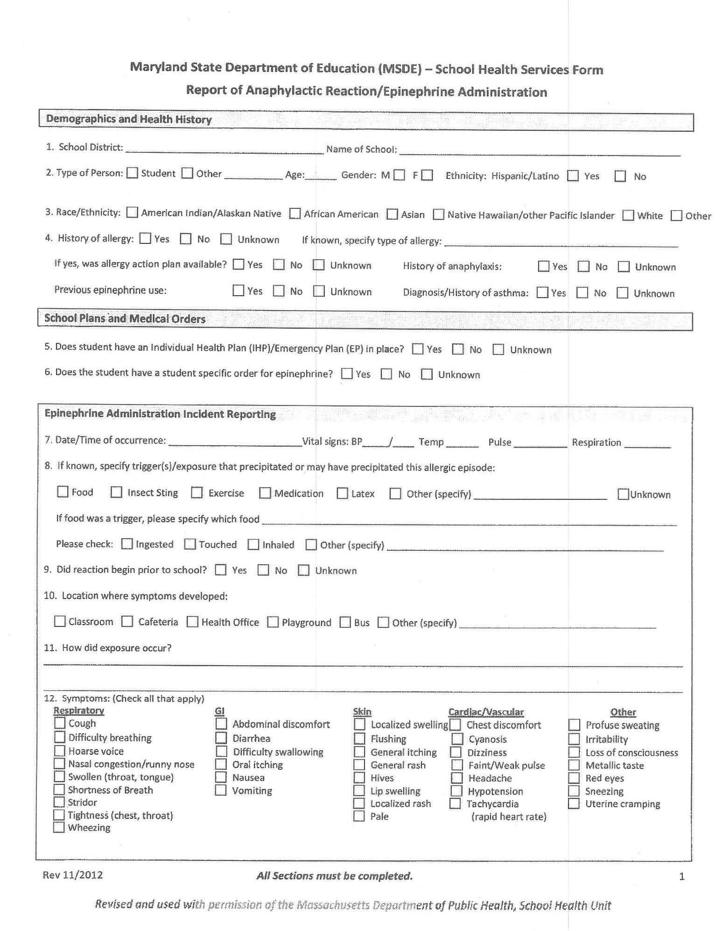
APPENDIX G

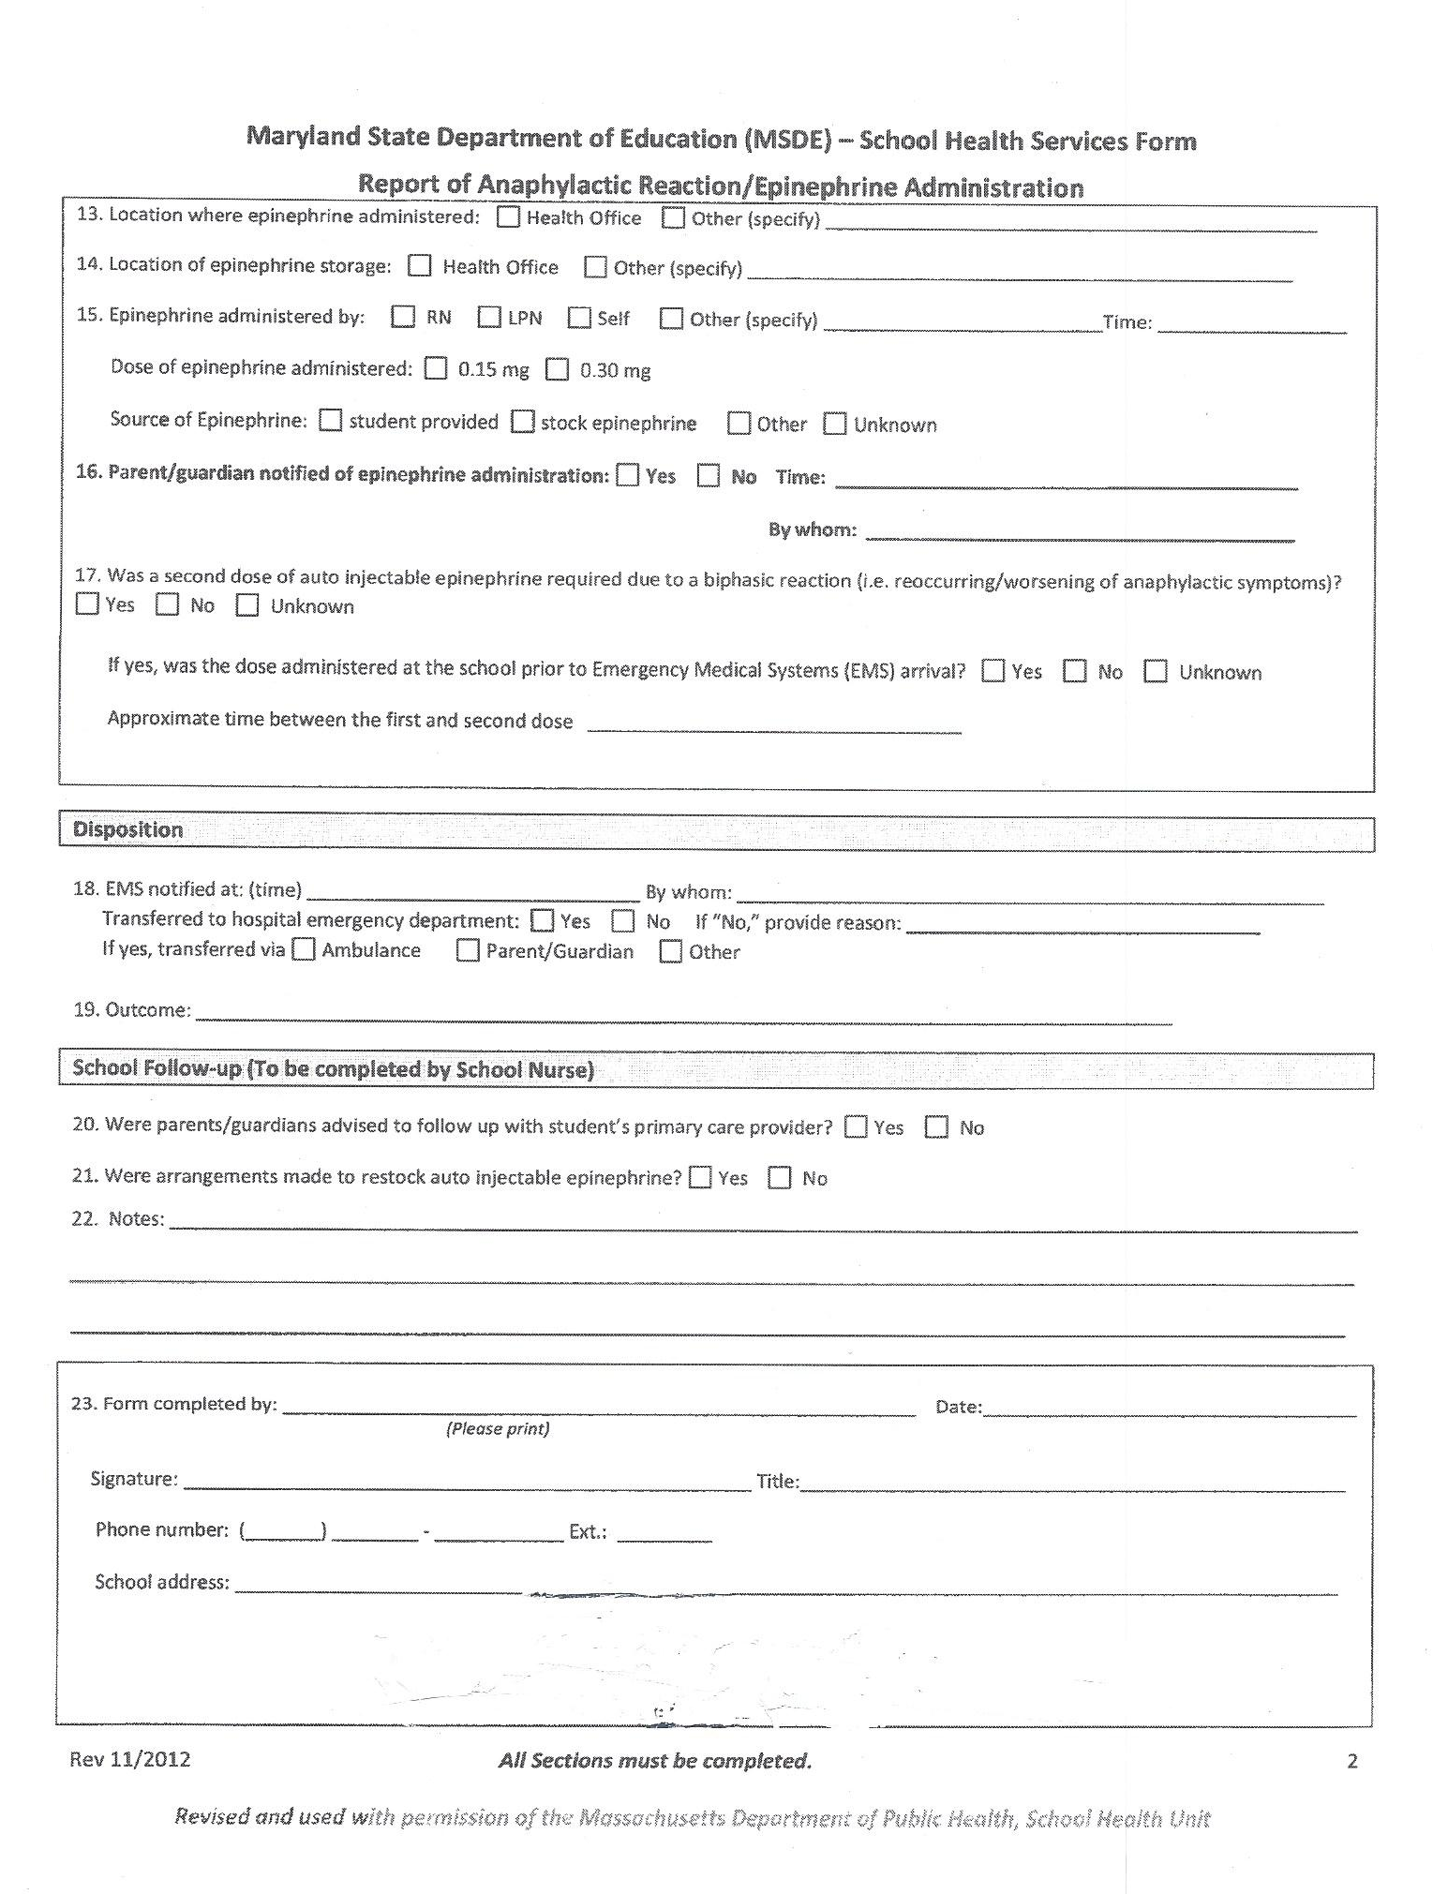

APPENDIX H
General Use Epinephrine Compliance Checklist

School Name ENTER SCHOOL NAME.
School Year ENTER SCHOOL YEAR.
Name of School Nurse/Licensed Health Care Practitioner ENTER SCH NURSE/PRACTIONER.

Criteria | Yes | No
Provide a completed copy of the school’s General Use Epinephrine Policy and Procedure which must include: | ☐ | ☐
- A copy of the statement of policy authorization and adoption distributed to the school community and included in the parent handbook. | ☐ | ☐
- A copy of the signed statement of authorization to obtain and store auto-injectable epinephrine | ☐ | ☐
- The Physician/Licensed Prescriber’s signature acknowledging that he or she has reviewed the document and all applicable documents and found them to be acceptable. | ☐ | ☐
- A copy of the list of impacted personnel who have completed training on the signs and symptoms of anaphylaxis, and auto-injectable epinephrine as described in the statement of training. | ☐ | ☐
- A copy of the school’s anaphylaxis response protocol | ☐ | ☐
Provide the name, address, phone number and e-mail address for the physician who has provided the medical authorization and medical direction. | ☐ | ☐
Provide a copy of the signed physician/licensed prescriber’s standing orders. | ☐ | ☐
Provide a copy of the training material used to train all faculty and staff in the signs and symptoms of anaphylaxis | ☐ | ☐
Provide a copy of the training material used to train impacted staff in anaphylaxis, proper use of auto-injectable epinephrine, and the school’s anaphylaxis response protocol | ☐ | ☐
Provide the name, address, telephone number, e-mail address and title of the licensed health care practitioner who will provide the training. | ☐ | ☐

________________________________________ _______________
Administrator’s Signature Date

________________________________________ _______________
School Nurse/Licensed health care practitioner Date

________________________________________ _______________
Office of Risk Management Date

_______________________________________ _______________
General Liability Certificate Number Date

