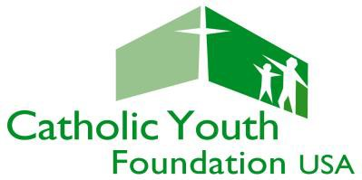
Deadline: Friday, April 28, 2017
NCYC SCHOLARSHIP APPLICATION (2017)
Submit to: Diocesan Office of Youth Ministry or the Diocesan NCYC Delegation Leader

Please read the NCYC Scholarship Application Instructions prior to completing this application. Representatives of the parish, school, or organization applying for NCYC scholarship funds should complete/submit this scholarship application form, along with the required narrative, to the Diocesan Office of Youth Ministry or the Diocesan NCYC Delegation Leader by Friday, April 28, 2017.

Please Print Legibly or Type.

Parish, School, or Organization Diocese Name of Person Submitting Application Address City/State/Zip Code Phone Email

Please provide the requested information below.
 |  | Youth | Adult
A | Number of Participants to be Funded by this Application
B | Projected Per Person Financial/Scholarship Need | $ | $
C | Total Scholarship Request (add youth and adult) | $

Please attach a narrative explaining why this parish, school, or organization is requesting scholarship funds and who these funds will serve. Explain how the scholarship money will help develop or support the local and/or diocesan youth ministry efforts. Refer to the scholarship criteria to support reasons for requesting scholarship funds. Do not include the names of youth or adults who may receive scholarship funds. Please limit the narrative to one double-spaced typewritten page.

Signature of Applicant Date

Submit this completed form, along with the requested narrative, to your Diocesan Office of Youth Ministry and/or the Diocesan Director/NCYC Delegation Leader no later than Friday, April 28, 2017.

ALL SCHOLARSHIP APPLICATIONS FROM YOUR DIOCESE MUST BE SUBMITTED TOGETHER BY THE DIOCESAN DIRECTOR/DELEGATION LEADER USING THE DIOCESAN NCYC SCHOLARSHIP SUMMARY FORM.

Diocesan Director/Delegation Leader Initials

Scholarship Application Form – NFCYM, Inc. (2014)

